I want you to become a Grandmaster.
So let me explain something to you ...
The Event object is automatically passed to all event handlers. An event handler is just a piece of code, or function, that executes code when an event happens. In our example, the function loadSecret() is our event handler.
That is why we could pass in the Event object when defining our onsubmit event handler, like this:
onsubmit="loadSecret(event)";
Important: this is the recommended way of passing the event object into the loadSecret() function.
Now, in the video I also mentioned that you can directly use the event keyword and access the Event object directly inside of the loadSecret() function. This is only possible because one can access the current event through window.event. Just using event is implicitly accessing window.event.
What is the problem with this approach?
Answer: it is currently being phased out. Although it works in Chrome, it may not work properly in other browsers. Here is a snapshot from MDN's website.

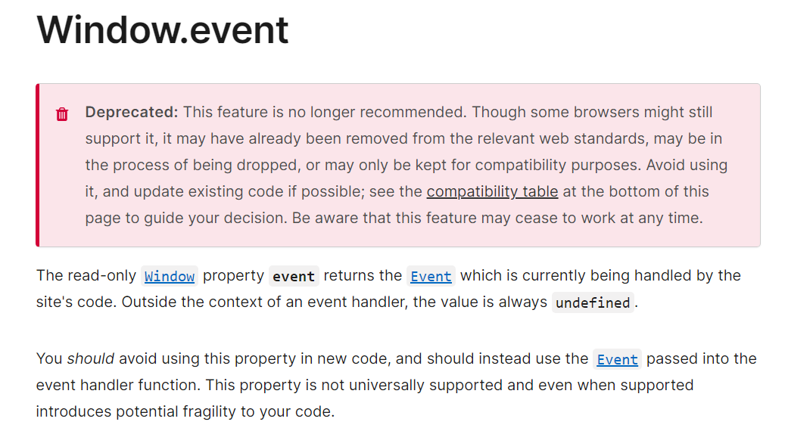
Hope this is making sense.
Let's march on.

